JOINING 2 TABLES USING JOIN CLAUSE

TYPES OF JIN COMMANDS

1.outer join

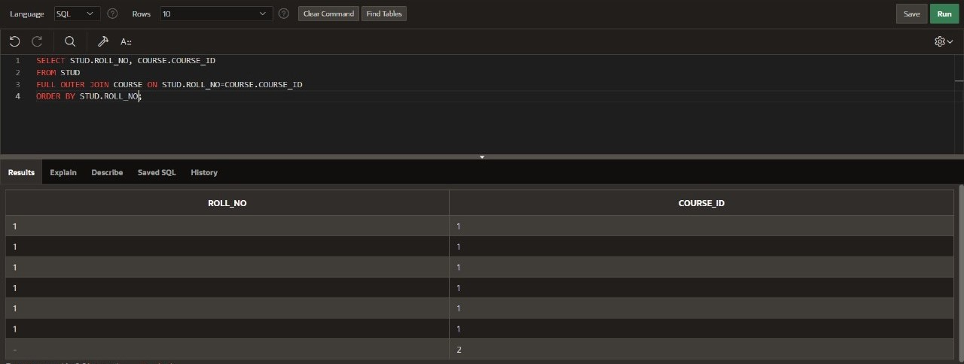

2.left join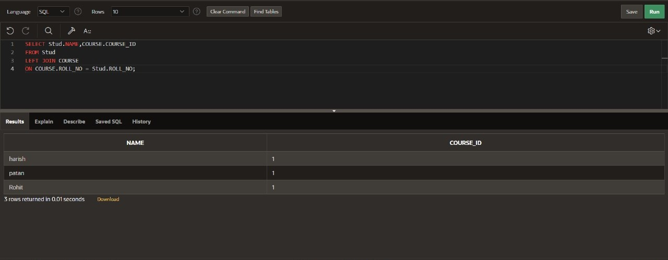

3.self join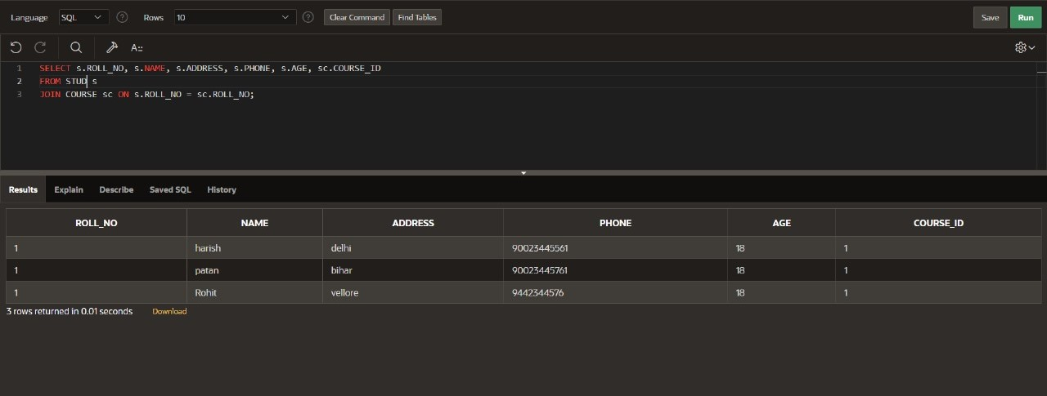

4.inner join